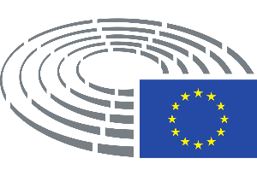

Dimitrios Papadimoulis
Vice-President of the European Parliament

To the attention of:

Mr. David Maria Sassoli
President of the European Parliament

Mr. Manfred Weber
President of the EPP Political Group in the European Parliament

Mrs. Iratxe García Pérez
President of the S&D Political Group in the European Parliament

Mr. Dacian Cioloș
President of the Renew Europe Political Group in the European Parliament

Mrs. Ska Keller and Mr. Philippe Lamberts
Co-Presidents of the Greens/EFA Political Group in the European Parliament

Mr. Ryszard Legutko and Mr. Raffaele Fitto
Co-Presidents of the ECR Political Group in the European Parliament

Mrs. Manon Aubry and Mr. Martin Schirdewan
Co-Presidents of the GUE/NGL Political Group in the European Parliament

16 November 2020

Subject: Total prohibition of any public gathering of more than three persons throughout Greece from 15 November until 18 November 2020

Dear President Sassoli,

Dear Presidents of the Political Groups,

Since the outbreak of the pandemic, the Parliament has taken all necessary measures to ensure continuity and its proper functioning, guaranteeing democracy at the highest EU level. Moreover, the Parliament, in its resolution of 13 November 2020, underlined that even in emergency situations, the fundamental principles of rule of law, democracy and the respect of fundamental rights should prevail.
The Covid-19 pandemic has been used as an excuse in some countries, even in EU Member States, for the imposition of measures, which undermine democracy and the rule of law. The Parliament has already identified and condemned with relevant resolutions such cases in Hungary and Poland. The Commission, in its 2020 Rule of Law Report, has also underlined certain and dangerous shortcomings in rule of law issues throughout the Union.

This year, in the occasion of the commemoration of the 17 November 1973 anti-fascist student revolution against the Greek dictatorship, the organisers had already decided to take very strict measures of social distancing and preventive actions for the protection of the public health against the pandemic. The Greek government, instead of coordinating with the organisers for the proper organisation of these restricted events, regrettably decided to prohibit, specifically from 15 November until 18 November, any public gathering of more than three persons throughout the whole country, with the excuse that especially for that period the tightening of the measures against the pandemic is necessary. This unprecedented and extreme decision actually targets particularly and on purpose any commemoration of this important and historic event for democracy in Greece and Europe.

This unacceptable decision of the Greek government is similar to decisions taken only twice in Greece in the past, on 21 April during the military coup and on 17 November 1973. The total prohibition of gathering fully suspends the fundamental right to assembly, as enshrined in Article 11 of the Greek Constitution, Article 11 of the ECHR and Article 12 of the Charter of Fundamental Rights of the EU. It is also noteworthy that, on 15 November, the Greek Association of Judges and Prosecutors characterised this decision as unconstitutional and asked for its immediate revocation.

During the challenging period of the pandemic, our House proved to be the frontrunner and actively protected rule of law and democracy in Europe. It is essential for the Parliament to ensure that only proportionate measures are taken due to the pandemic and that there is no any setback regarding the rule of law and fundamental rights in the Union, not allowing the pandemic to be used as a pretext for undermining democracy in Europe.

Yours sincerely,
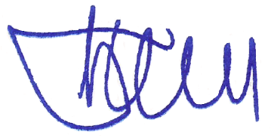
Dimitrios Papadimoulis

https://www.europarl.europa.eu/doceo/document/TA-9-2020-0307_EN.pdf
https://eur-lex.europa.eu/legal-content/EN/TXT/PDF/?uri=CELEX:52020DC0580&from=EN

